Incident of 21 jan 2025

Series of incidents happened from 18 jan 2025
- Following the labour meeting on 18 jan with instructions from deputy commissioner of labour, discussed with visweswar reddy
- Visweswar reddy asked us to come to office on 20 jan 2025 Monday 11.00 am
- When asked for details of location on Monday, he said to attend by evening because siva byrapuneni’s mother was hospitalized in kims hospital
- Attended office at evening time around 6.00pm but they made us wait until an hour around 7.00pm
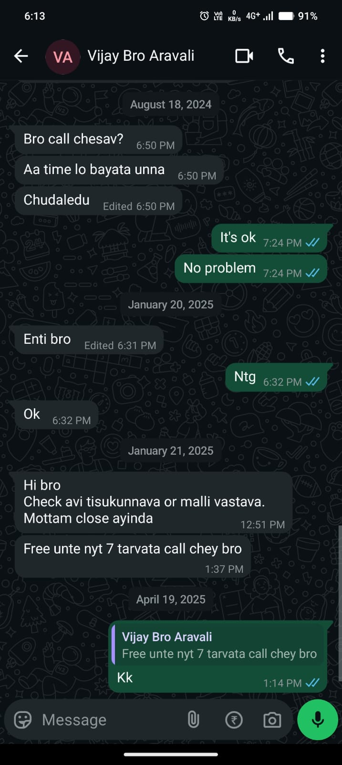
- Employee named vijaykumaar, asked me why did I come to ofc the exact time of my attendance can be seen through chat
- He dared to text me because, he was my senior since school days till btech

- At 7.00pm visweswar called to conference room and barely re-iterated the issue, by asking what mistakes did I do, who are other employees involved in complaints, etc.,
- He said, lawyer was busy at this time, lets meet tomorrow again
- But I didn’t went alone, I took one of my relative along with me
- Mural babai, who stays in Ongole
- The next day 21 jan morning 11.00 I attended
- Visweswar asked if my grandfather and family members , everyone should come - which I denied,
- He asked us to agree for apology – I accepted
- But shown some illegal documents which states as if
  - My complaints were false
  - I complained to defame and damage their reputation
  - I resigned not because of harassment
I denied

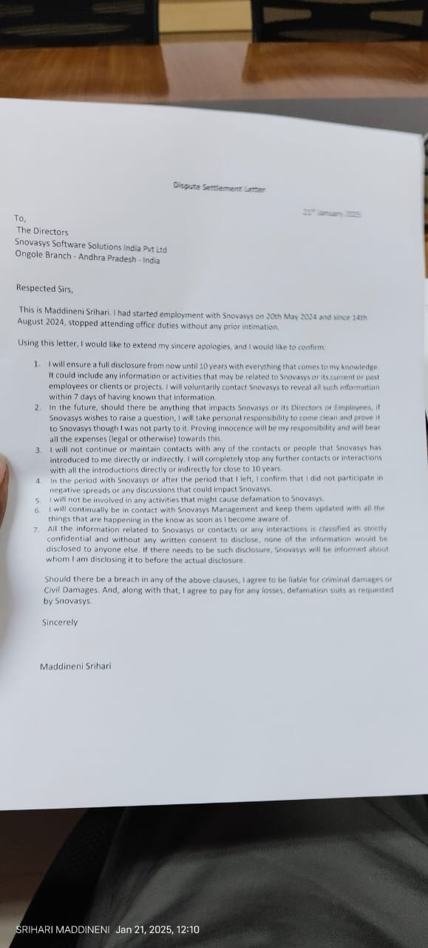
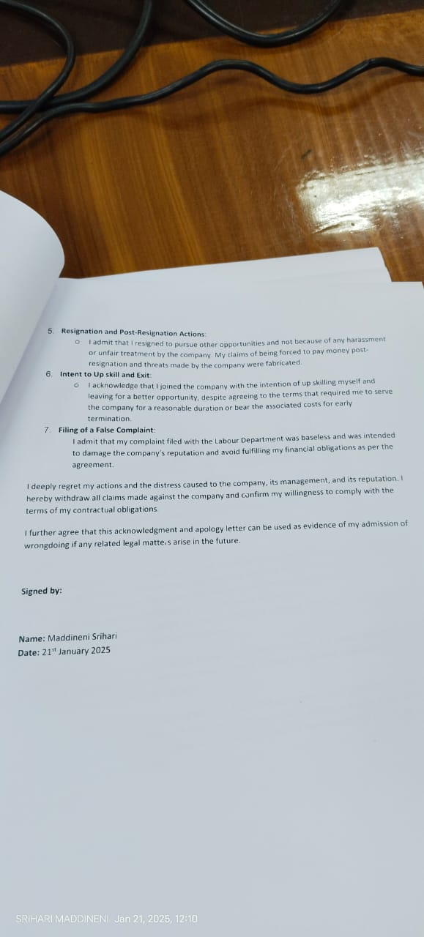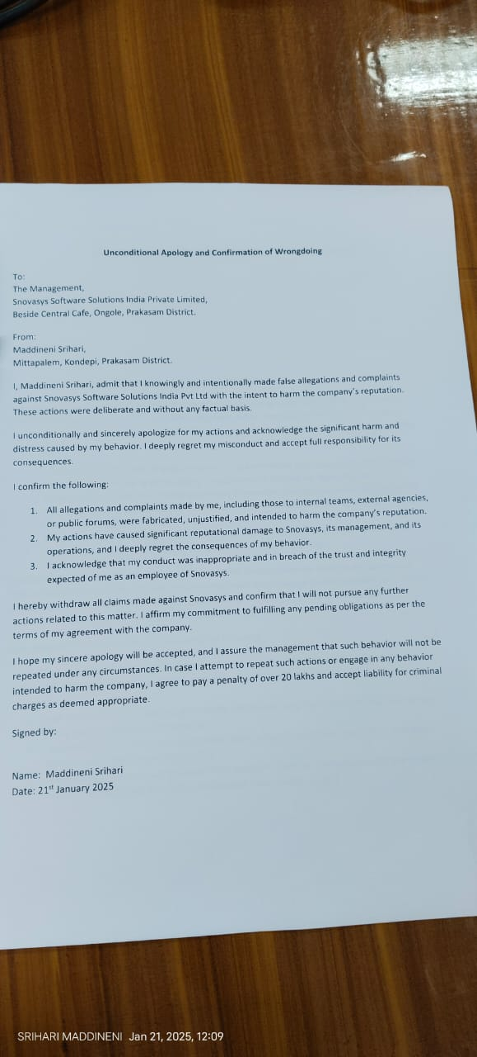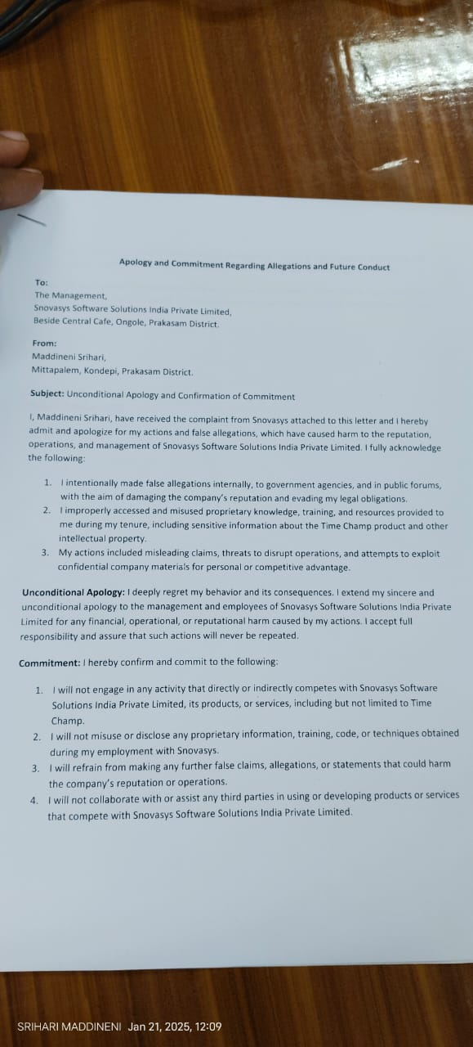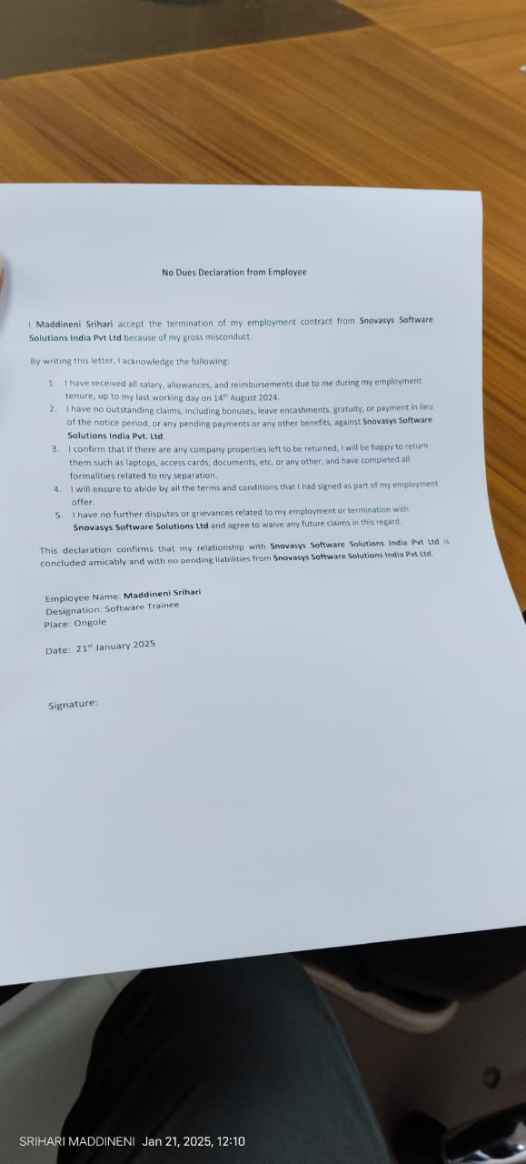
- 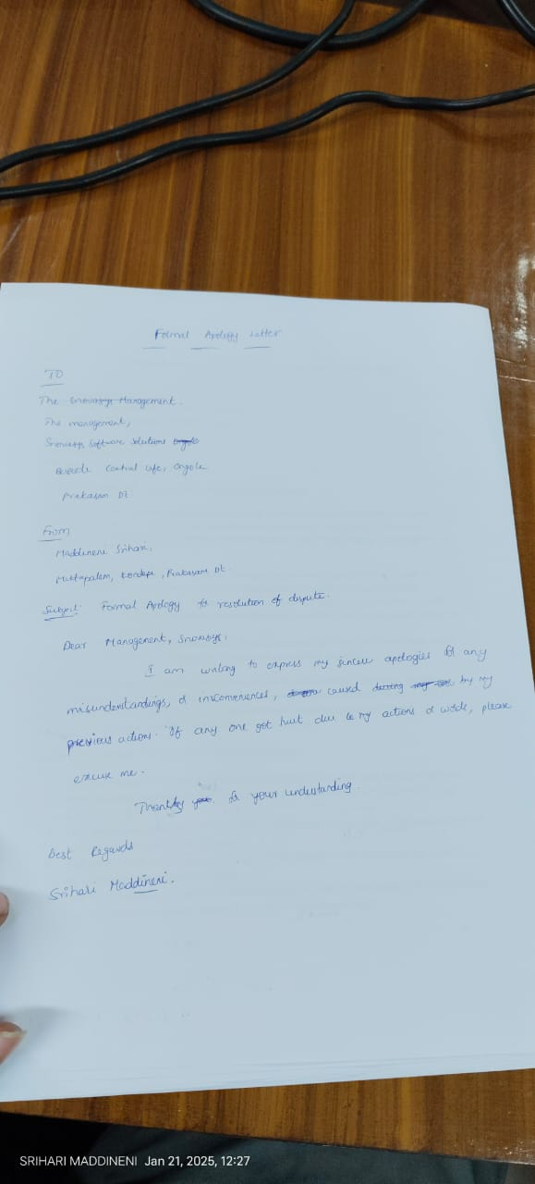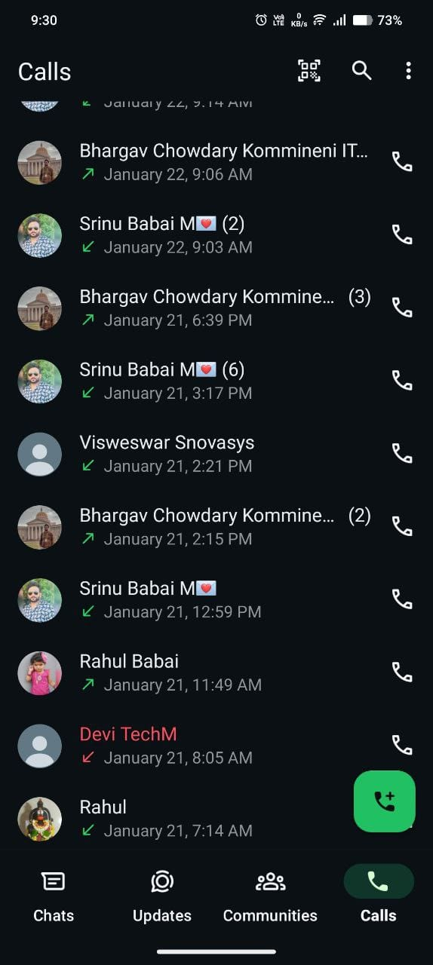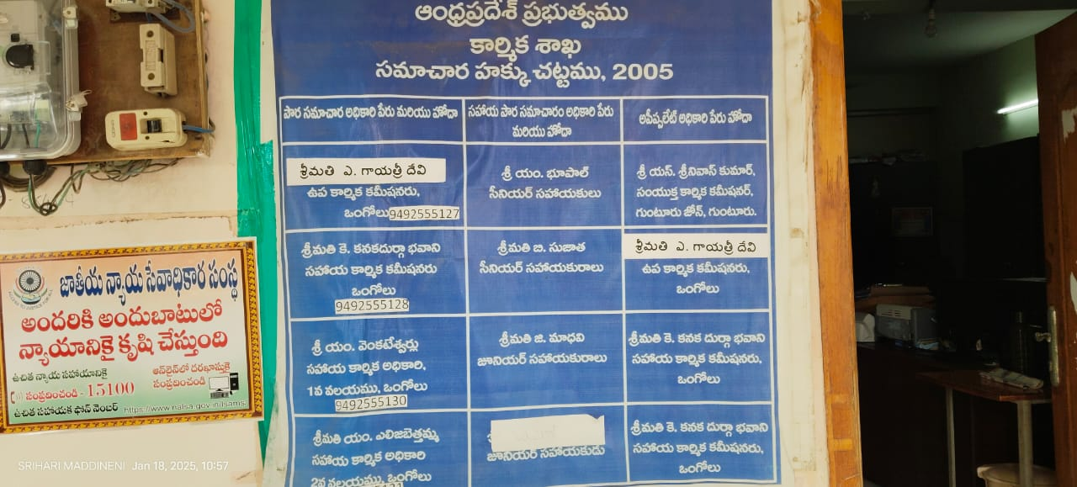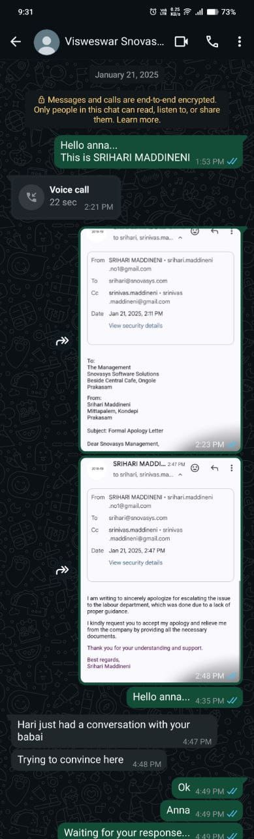
- If I was threatening them at 4.30 inside their office, and visweswar is looking at stopping me, how can I chat with him at the same time???
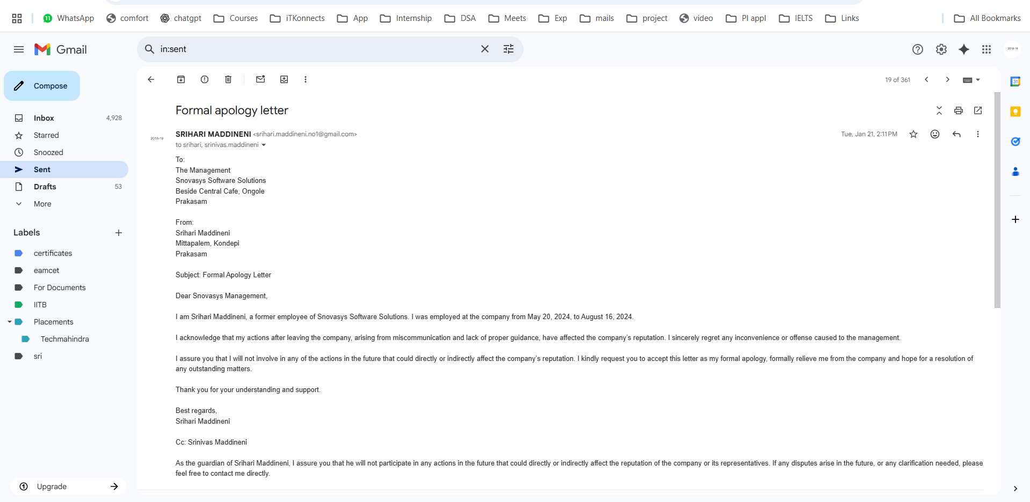

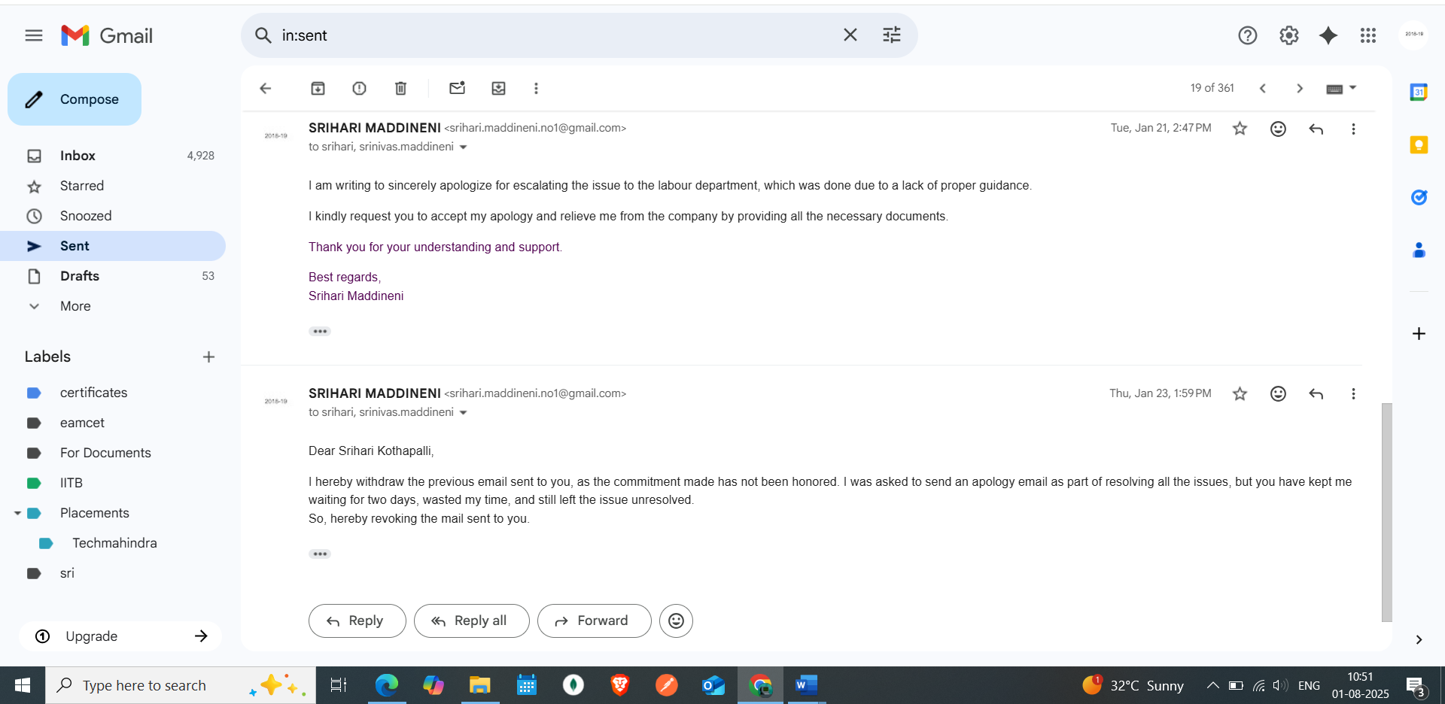

- Visweswar asked me to sent apologies to srihari kothapalli, and told as if srihari kothapalli is the final decision maker to stop all these
- So I did accordingly

- 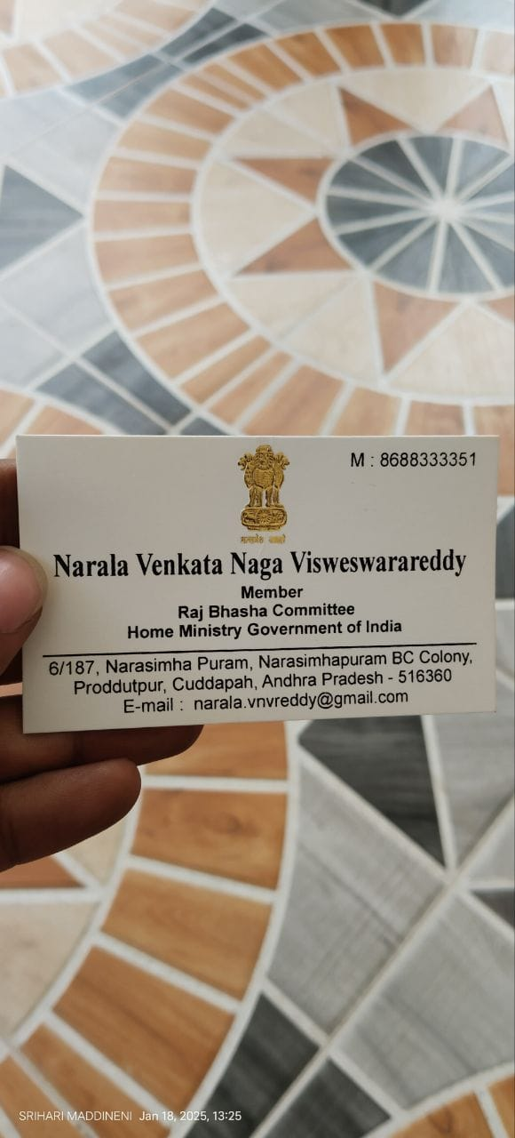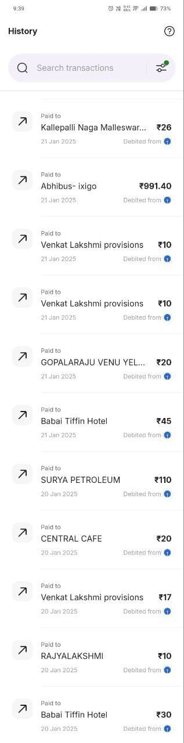
- I resigned their office not they terminated,
- Then how can I go myself to their office and threaten them and blame them for termination

- 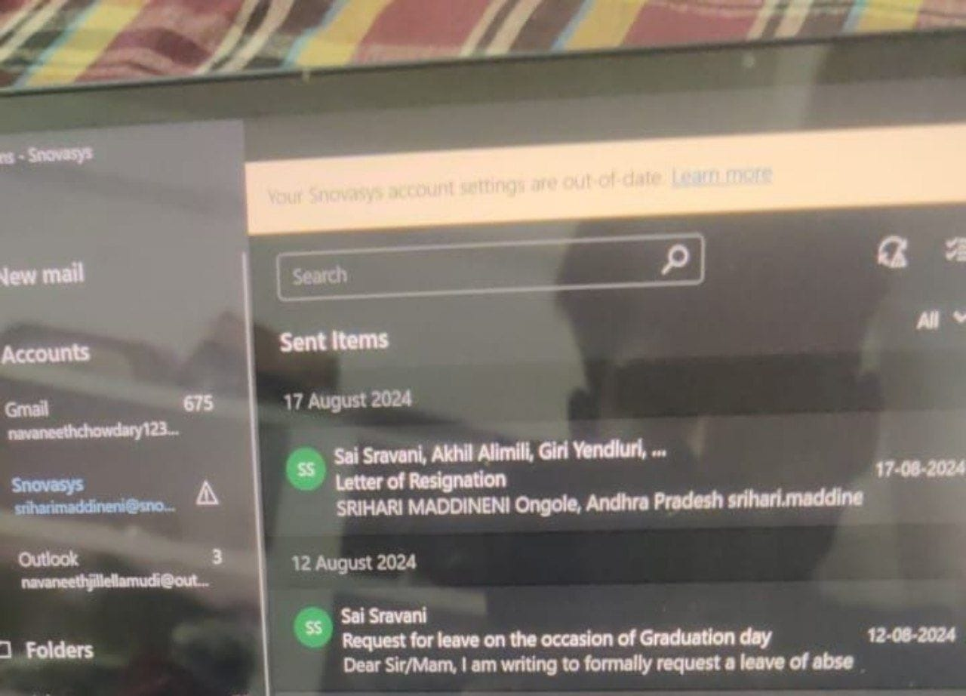
The next day also visweswar reddy tried to convince me and agreed as if they already did to other employees and they are following this procedure of documents with all and it was their policy

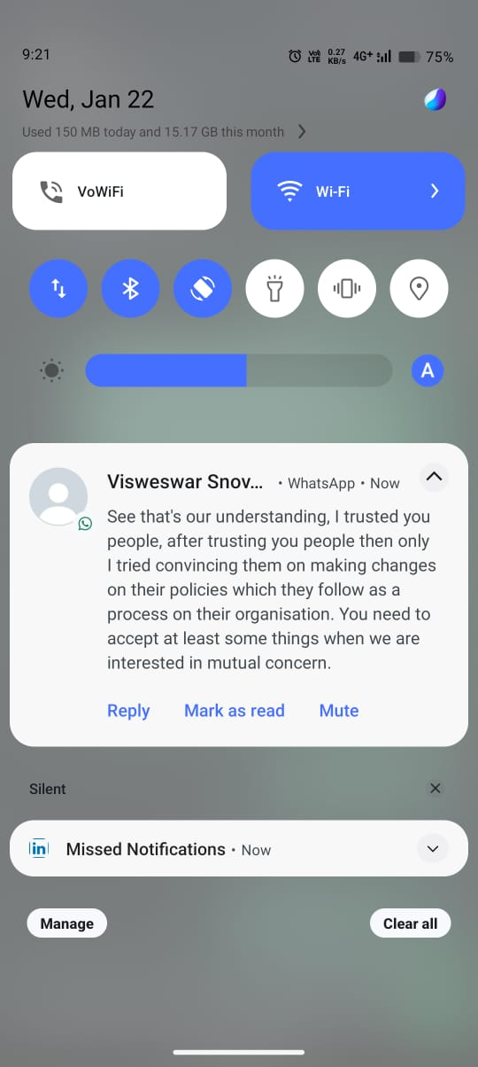
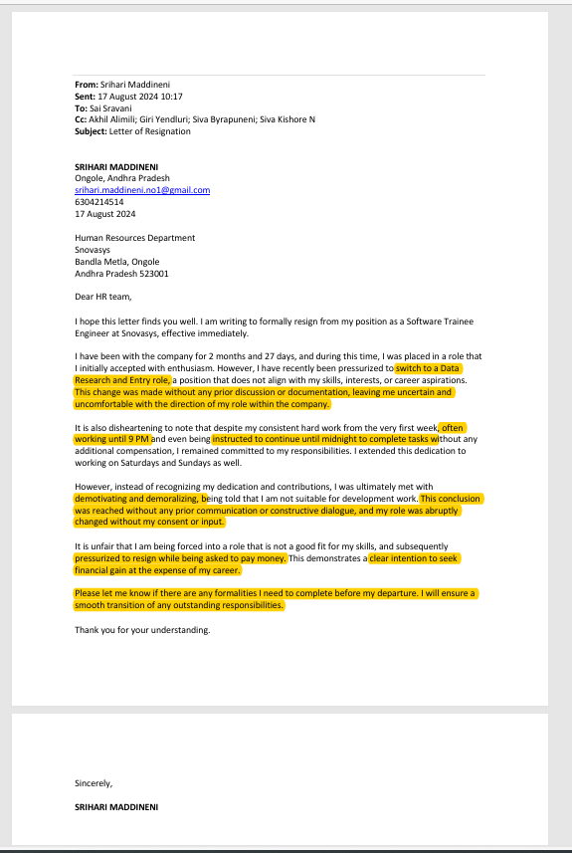

- After that, we didn’t agreed to sign on those documents
- I went away to hydereabad to resume my work
- On 22 jan also visweswar tried to convince me
- I denied
- I revoked the apology mail sent to srihari kothapalli

- On 15 february 2025, santosh named constable +91 87125 13052
- Called me to attend the police station as soon as possible
- After discussing the possibility of meeting, attended police station on 6th march evening
- Inspector vijay naik sir, was the incharge of the complaint filed on me
- It was related to data theft and code theft filed against me
- Inspector sir investigated, he understood everything and

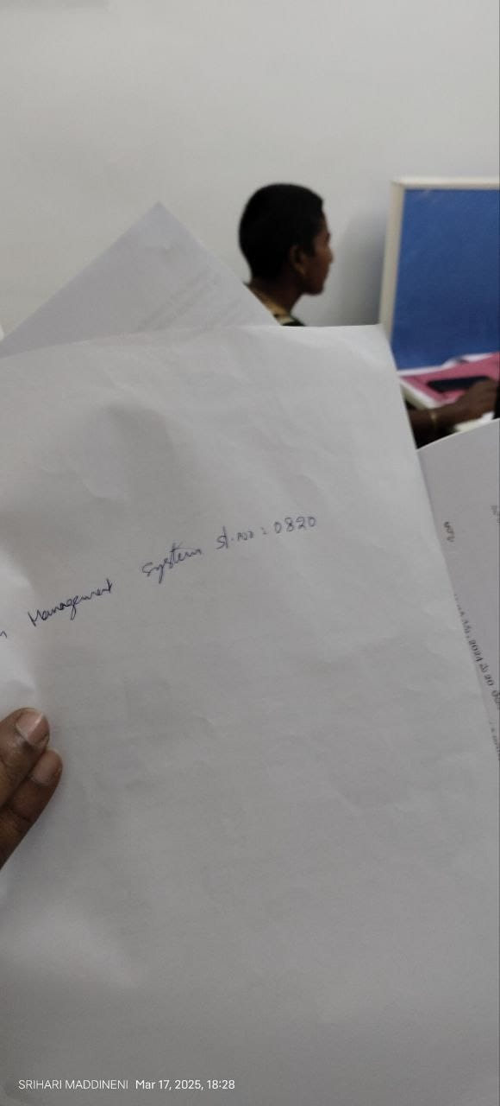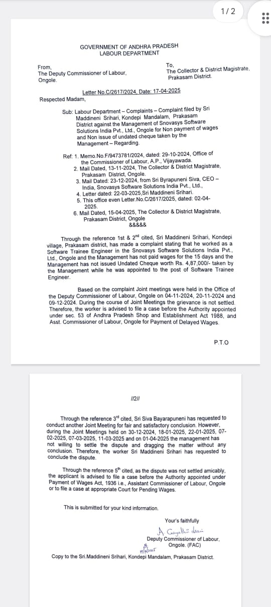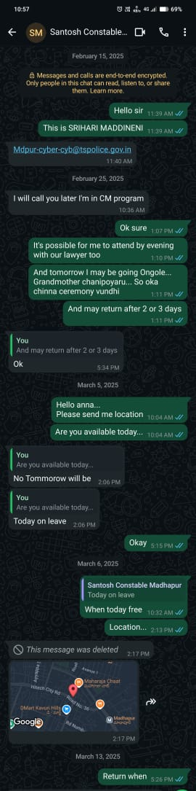

In series,
- 11th jan 2025 Saturday
- Went to town D.S.P (Rayapati srinivasulu sir) sir, to request action against harassment,
- One town police stations CI , being present there, stated as if I am the culprit and CI got a complaint in dec 2024, regarding agreement/bond breaking, and some workplace issues by siva byrapuneni from snovasys software solutions.
- DSP sir, instructed CI sir, to investigate the matter clearly
- CI sir, told to meet on next day on 12th jan sunday
- 12th jan 2025 sunday
- I went to 1 town police station, company manager siva byrapuneni and some person named, Ramakrishna, have come
- CI sir , in a hurry asked SI Tyagaraju sir, to go through the issue,
- SI T.Tyagaraju sir, not aware of complete issue, asked if I had signed on offer letter of 3 years of bond or not , I agreed,
- He said, to repay the cheque amount or join the company again
- I tried to explain the issue, which didn’t felt useful
- SI instructed to take a decision whether money payment or re joining in company
- Asked me to attend by evening again
- Attended, station, explained clearly about the background issue, SI understood
- Asked to come next day with a decision to file fir against me or not
- 13th January 2025 Monday
- We went with a counter complaint.
- SI investigated about false allegations like, training and all and we explained
- SI understood about false allgations made regarding training and expenditures by the company
- Took our counter complaint and when asked for acknowledgement, he said as if it will be provided after review by CI
- 15th jan 2025 wednesday
- Mailed to deputy commissioner of labour, stating we are contemplating the issue to concerned union ministry of labour, and ministry of corporate affairs to stop the harassment from srihari kothapalli, siva byrapuneni, giri yendluri, and visweswar reddy.

- 17th jan Friday
- We are called upon to station,
- Discussion between both parties, done in presence of CI
- Asked us to wait out for 10 mins
- SI came and suggested to settle outside with a third person as middlemen
- Siva byrapuneni demanded, atleast 75% of 4,87,000/- which we denied approximately (3,65,000) else he is gonna file fir on me
- 18th jan saturday
- Attended labour dept. joint meeting,
- Visweswar named some person, stating CEO friend , came and represented the issue
- Made false allegations regarding, some cyber crime issues such as code theft and data theft,
- When asked for clarification, no proofs were provided
- I offered my laptop be verified thoroughly, which they denied
- Commisoner of labor, suggested to settle , and not to make complications
- we agreed upon with each other
- visweswar and us, with labour commisoner and visweswar asked us to come to office on Monday 20th jan to settle the issue.
- 20th jan 2025
- When asked about the location details, told us to come to office.
- And then suddenly told as if siva byrapuneni mother is in hospital (KIMS) that day in a serious situation, kims hospital
- So, visweswar reddy asked to come in the evening time
- When went, we are made wait for an hour from 6.10 and at around 7.00 pm, he asked to come to conference hall
- He barely started re iterating the issue and made me feel awkward and denied to answer some questions
- Informed to come next day again as it was already late and issue cant be resolved due to lack of lawyer appointments.
- Off the records: ( we offered 50,000- 1,00,000/- amount not to make any issues even In future. Which agreed actually)
- 21 jan 2025 Tuesday
- Asked us to come to office by 11.00 am
- We went
- Barely re iterated the issue
- Asked us to apologise
- We accepted
- Asked us to tell about other employees, if involved in this legal battle which I said as if none involved
- Gave some illegal documents which states , false allegtions against me and stating all my complaitns were false and fabricated – we denied
- Asked to apologise to srihari kothapalli and also to mail as if all the complaints were false, which I denied
- Asked to mail to Srihari kothapalli as per our version of apology – I did
- Made me wait until 8.00pm without any answer
- Siva byrapuneni was not present at the office and was in hospital as stated by visweswar reddy
- I saw siva byrapuneni in the evening around 6.00pm
- I went to hyd without any delay to resume work as I was staying on ongole for already 2 days
- 22nd jan 2025
- Visweswar tried to convince me through whatsapp to agree upon false allegations, which I denied
- 23rd jan
- Revoked apology mail sent to CEO srihari kothapalli, as mutual agreement didn’t done
- 25th jan
- Updated through a letter and got acknowledged in person, about the issue of dispute settlement which turned out to be more harassment from visweswar, srihari kothapalli and company
- Joint meeting rescheduled to 31st jan
- 29th jan
- I requested to reschedule the joint meeting
- 10th feb 2025
- CI Nagaraju sir, called me at 9.30 pm to attend to 1 town police station, to file an fir against me from siva byrapuneni, snovasys software solutions
- When I asked to file my fir also against them, he stated as if my complaint was missing somewhere
- Immediately mailed to SP office regarding malicious retaliation and harassment , along with Collectorate and 1 town police station in CC.
- 12th feb 2025
- Mailed to lodge a compliant to SP Office, ongole
- 15th feb 2025
- Santosh, Madhapur police station constable, cyber crime called me to attend to station regarding a complaint on cyber crime issues, by visweswar reddy snovasys software solutions.
- Informed the background of issue and mailed to the correspondent department
- 6th march 2025
- Attended Madhapur police station and went on a discussion with inspector Vijay naik sir, visweswar reddy from snovasys (as Chief risk officer)
- Inspector asked for proofs which they failed to submit
- Inspector instructed not to waste time with false allegations without proper evidence
- After a few days submitted our concern and submission stating their harassment since last 6 months and misleading cyber crime issue at sudden in Madhapur police station

- 7th march
- Attended joint meeting in labour department ongole
- Informed about Madhapur station issue.
Adjourned to 11th march

Attachments:
- Counter complaint

Incident of 21 jan 2025
In series,
- 11th jan 2025 Saturday
- Went to town D.S.P (Rayapati srinivasulu sir) sir, to request action against harassment,
- One town police stations CI , being present there, stated as if I am the culprit and CI got a complaint in dec 2024, regarding agreement/bond breaking, and some workplace issues by siva byrapuneni from snovasys software solutions.
- DSP sir, instructed CI sir, to investigate the matter clearly
- CI sir, told to meet on next day on 12th jan sunday
- 12th jan 2025 sunday
- I went to 1 town police station, company manager siva byrapuneni and some person named, Ramakrishna, have come
- CI sir , in a hurry asked SI Tyagaraju sir, to go through the issue,
- SI T.Tyagaraju sir, not aware of complete issue, asked if I had signed on offer letter of 3 years of bond or not , I agreed,
- He said, to repay the cheque amount or join the company again
- I tried to explain the issue, which didn’t felt useful
- SI instructed to take a decision whether money payment or re joining in company
- Asked me to attend by evening again
- Attended, station, explained clearly about the background issue, SI understood
- Asked to come next day with a decision to file fir against me or not
- 13th January 2025 Monday
- We went with a counter complaint.
- SI investigated about false allegations like, training and all and we explained
- SI understood about false allgations made regarding training and expenditures by the company
- Took our counter complaint and when asked for acknowledgement, he said as if it will be provided after review by CI
- 15th jan 2025 wednesday
- Mailed to deputy commissioner of labour, stating we are contemplating the issue to concerned union ministry of labour, and ministry of corporate affairs to stop the harassment from srihari kothapalli, siva byrapuneni, giri yendluri, and visweswar reddy.

- 17th jan Friday
- We are called upon to station,
- Discussion between both parties, done in presence of CI
- Asked us to wait out for 10 mins
- SI came and suggested to settle outside with a third person as middlemen
- Siva byrapuneni demanded, atleast 75% of 4,87,000/- which we denied approximately (3,65,000) else he is gonna file fir on me
- 18th jan saturday
- Attended labour dept. joint meeting,
- Visweswar named some person, stating CEO friend , came and represented the issue
- Made false allegations regarding, some cyber crime issues such as code theft and data theft,
- When asked for clarification, no proofs were provided
- I offered my laptop be verified thoroughly, which they denied
- Commisoner of labor, suggested to settle , and not to make complications
- we agreed upon with each other
- visweswar and us, with labour commisoner and visweswar asked us to come to office on Monday 20th jan to settle the issue.
- 20th jan 2025
- When asked about the location details, told us to come to office.
- And then suddenly told as if siva byrapuneni mother is in hospital (KIMS) that day in a serious situation, kims hospital
- So, visweswar reddy asked to come in the evening time
- When went, we are made wait for an hour from 6.10 and at around 7.00 pm, he asked to come to conference hall
- He barely started re iterating the issue and made me feel awkward and denied to answer some questions
- Informed to come next day again as it was already late and issue cant be resolved due to lack of lawyer appointments.
- Off the records: ( we offered 50,000- 1,00,000/- amount not to make any issues even In future. Which agreed actually)
- 21 jan 2025 Tuesday
- Asked us to come to office by 11.00 am
- We went
- Barely re iterated the issue
- Asked us to apologise
- We accepted
- Asked us to tell about other employees, if involved in this legal battle which I said as if none involved
- Gave some illegal documents which states , false allegtions against me and stating all my complaitns were false and fabricated – we denied
- Asked to apologise to srihari kothapalli and also to mail as if all the complaints were false, which I denied
- Asked to mail to Srihari kothapalli as per our version of apology – I did
- Made me wait until 8.00pm without any answer
- Siva byrapuneni was not present at the office and was in hospital as stated by visweswar reddy
- I saw siva byrapuneni in the evening around 6.00pm
- I went to hyd without any delay to resume work as I was staying on ongole for already 2 days
- 22nd jan 2025
- Visweswar tried to convince me through whatsapp to agree upon false allegations, which I denied
- 23rd jan
- Revoked apology mail sent to CEO srihari kothapalli, as mutual agreement didn’t done
- 25th jan
- Updated through a letter and got acknowledged in person, about the issue of dispute settlement which turned out to be more harassment from visweswar, srihari kothapalli and company
- Joint meeting rescheduled to 31st jan
- 29th jan
- I requested to reschedule the joint meeting
- 10th feb 2025
- CI Nagaraju sir, called me at 9.30 pm to attend to 1 town police station, to file an fir against me from siva byrapuneni, snovasys software solutions
- When I asked to file my fir also against them, he stated as if my complaint was missing somewhere
- Immediately mailed to SP office regarding malicious retaliation and harassment , along with Collectorate and 1 town police station in CC.
- 12th feb 2025
- Mailed to lodge a compliant to SP Office, ongole
- 15th feb 2025
- Santosh, Madhapur police station constable, cyber crime called me to attend to station regarding a complaint on cyber crime issues, by visweswar reddy snovasys software solutions.
- Informed the background of issue and mailed to the correspondent department
- 6th march 2025
- Attended Madhapur police station and went on a discussion with inspector Vijay naik sir, visweswar reddy from snovasys (as Chief risk officer)
- Inspector asked for proofs which they failed to submit
- Inspector instructed not to waste time with false allegations without proper evidence
- After a few days submitted our concern and submission stating their harassment since last 6 months and misleading cyber crime issue at sudden in Madhapur police station

- 7th march
- Attended joint meeting in labour department ongole
- Informed about Madhapur station issue.
Adjourned to 11th march

Attachments:
- Counter complaint

